EXPT NO:3 | Designing Multivariate Patterns
DATE: 12.01.2026 | Designing Multivariate Patterns

PRE-LAB QUESTIONS (PROVIDE BRIEF ANSWERS TO THE FOLLOWING QUESTIONS)
- Why is multivariate analysis essential in real-world AI problems?
Multivariate analysis is essential in real-world AI problems because it analyzes multiple related variables together, capturing complex relationships that single-variable analysis cannot. It improves prediction accuracy, supports feature selection, reduces redundancy, and enables better decision-making by reflecting the true, high-dimensional nature of real-world data.
- What challenges arise when visualizing high-dimensional data?
Visualizing high-dimensional data presents several challenges:
- Overcrowding and clutter: Too many variables can make plots confusing and hard to interpret.
- Dimensionality limits: Humans can effectively visualize only 2D or 3D representations.
- Information loss: Reducing dimensions may hide important patterns or relationships.
- Scalability issues: Visualizations become inefficient as data size and dimensions increase.
- Interpretation difficulty: Complex visuals can be misleading without proper context or domain knowledge.

- How does correlation analysis support feature selection?
Correlation analysis supports feature selection by identifying relationships between variables. Highly correlated features indicate redundancy, so one can be removed without significant information loss. It also helps select features that are strongly correlated with the target variable, improving model efficiency, reducing complexity, and minimizing overfitting.

- What are ethical concerns in healthcare data visualization?
Ethical concerns in healthcare data visualization include patient privacy and data confidentiality, potential misinterpretation or bias leading to incorrect clinical decisions, data misuse or unauthorized access, and the risk of misleading visualizations that oversimplify complex medical information. Ensuring anonymization, accuracy, fairness, and transparency is essential.

- Give examples of multivariate data in AI systems.
Examples of multivariate data in AI systems include:
- Healthcare AI: Age, BMI, blood pressure, glucose levels, and medical history for disease prediction.
- Recommendation systems: User age, preferences, browsing history, ratings, and location.
- Autonomous vehicles: Speed, distance to objects, camera images, LiDAR data, and GPS coordinates.
- Financial AI: Income, spending patterns, credit score, transaction history, and risk indicators.
- Smart agriculture: Soil type, moisture, temperature, rainfall, crop yield, and fertilizer usage.

IN-LAB EXERCISE:
OBJECTIVE:
To discover relationships among multiple variables using multivariate visualization.
SCENARIO:
A hospital analytics team studies patient health records to identify relationships between age, BMI, glucose levels, and blood pressure for early disease prediction.
IN-LAB TASKS (Using R Language)
- Generate scatter plot matrix
- Apply color encoding for age groups
- Identify correlated health indicators

(CODE: CONATAINS STUDENT ROLL NOS
SCREENSHOT OF CODE
SCREENSHOT OF OUTPUT)

CODE:
install.packages(c("GGally", "dplyr"))
library(GGally)
library(dplyr)
health <- read.csv("C:/Users/student/Downloads/3.healthcare_data.csv")
str(health)
head(health)
health <- health %>%
mutate(
Age_Group = cut(
Age,
breaks = c(0, 30, 50, 100),
labels = c("Young", "Middle", "Senior")
)
)
ggpairs(
health,
columns = c("Age", "Blood_Pressure", "Cholesterol", "Glucose_Level"),
aes(color = Age_Group, alpha = 0.7),
title = "Scatter Plot Matrix of Health Indicators"
)
health_numeric <- health %>%
select(Age, Blood_Pressure, Cholesterol, Glucose_Level)

correlation_matrix <- cor(
health_numeric,
use = "complete.obs"
)
print(correlation_matrix)

OUTPUT:

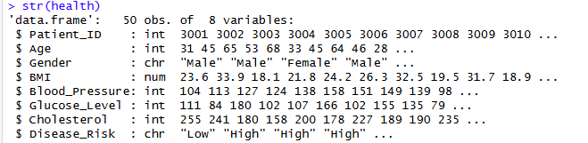
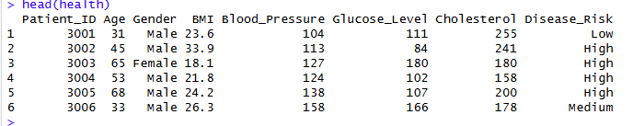

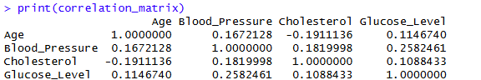
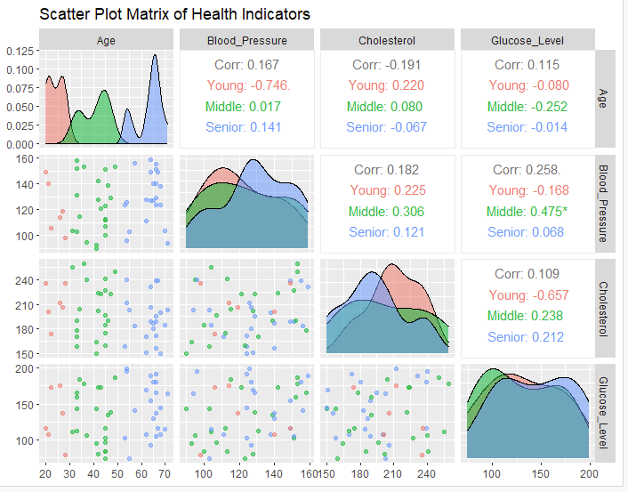

POST-LAB QUESTIONS (PROVIDE BRIEF ANSWERS TO THE FOLLOWING QUESTIONS)
- Which health parameters show strong correlation?
From the scatter plot matrix and correlation values:
- Blood Pressure and Glucose Level show the strongest positive correlation, particularly in the middle-aged group, indicating a higher combined metabolic risk.
- Blood Pressure and Cholesterol show a moderate positive correlation, again more evident among middle-aged patients.
- Other pairs involving Age (Age–BMI/Cholesterol/Glucose) show weak correlations.
Conclusion:
The most strongly correlated health parameters are Blood Pressure with Glucose Level, followed by Blood Pressure with Cholesterol.

- Why correlation does not imply causation in medical data?
Correlation does not imply causation in medical data because two variables may appear related due to confounding factors, shared risk influences, or coincidence, without one directly causing the other. Medical outcomes are affected by multiple biological, lifestyle, and environmental factors, so a statistical association alone cannot establish a cause–effect relationship without clinical evidence or controlled studies.

- How can these patterns assist predictive healthcare AI?
These patterns help predictive healthcare AI by identifying key risk indicators and their interactions, enabling better feature selection, risk stratification, and early disease prediction. Understanding correlations among variables allows models to detect high-risk patient profiles, improve prediction accuracy, and support timely, data-driven clinical decisions

- What visualization limitations exist for high-dimensional data?
Visualization of high-dimensional data has several limitations:
- Dimensionality constraints: Humans can effectively interpret only 2D or 3D visualizations.
- Visual clutter: As variables increase, plots become crowded and difficult to read.
- Information loss: Dimensionality reduction may hide important relationships.
- Scalability issues: Large datasets reduce clarity and performance.
- Interpretation challenges: Complex visuals can mislead without proper context or domain knowledge.

- How can dimensionality reduction improve visualization?
Dimensionality reduction improves visualization by compressing high-dimensional data into fewer meaningful dimensions while preserving key patterns. Techniques such as PCA and t-SNE reduce clutter, highlight hidden structures and clusters, improve interpretability, and make complex datasets easier to analyze visually and computationally.

ASSESSMENT
Description | Max Marks | Marks Awarded
Pre Lab Exercise | 5
In Lab Exercise | 10
Post Lab Exercise | 5
Viva | 10
Total | 30
Faculty Signature

